NAME:SHYAM SUNDAR
ROLL NO:241801268
Exercise 1
1.
create table DEPaT(ID int,name varchar(25));
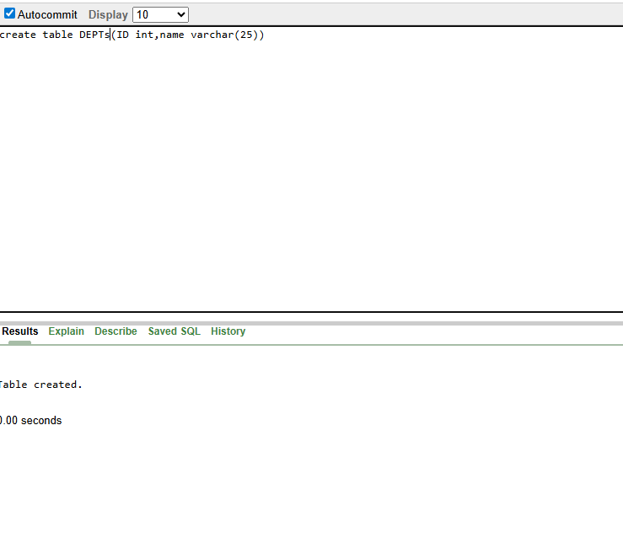

2,
create table EMPa(Id int,FIRST_NAME varchar(25),LAST_NAME varchar(25),DEPT_ID int);
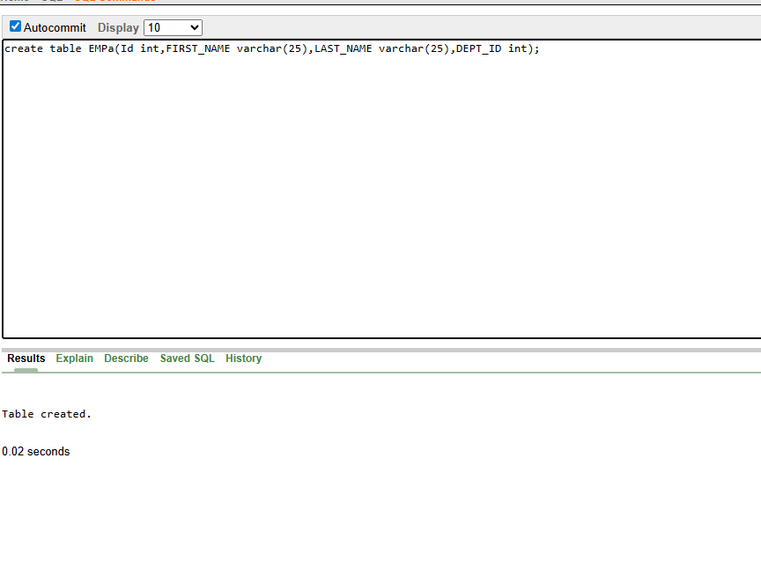
3,
alter table EMP modify( LAST_NAME varchar(50))
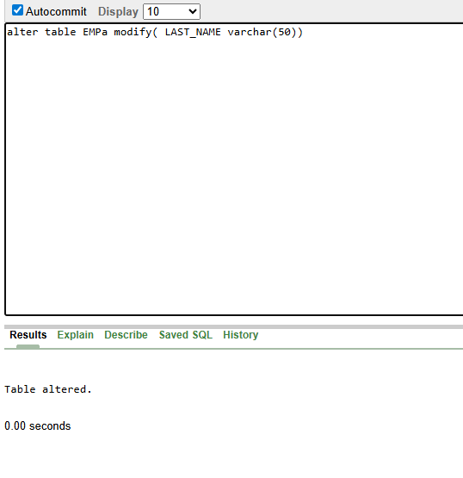
4,
create table EMPLOYEES2(ID int,FIRST_NAME varchar(25),LAST_NAME varchar(25),SALARY int,DEPT_ID int)
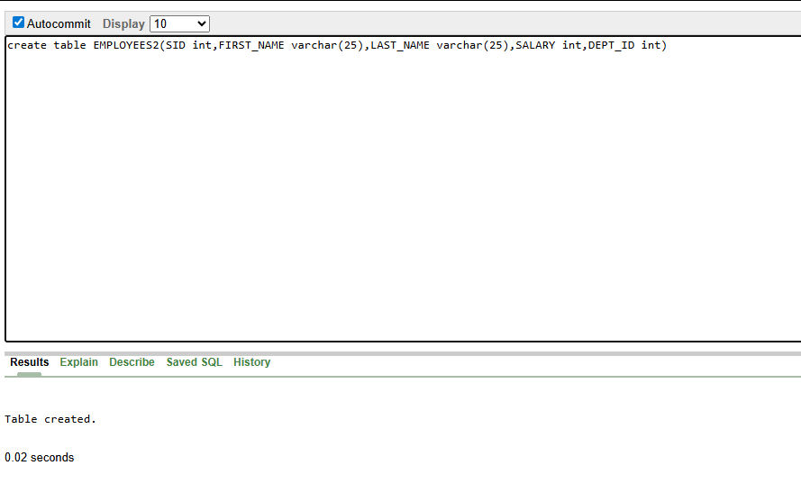
5,
drop table DEPPT;
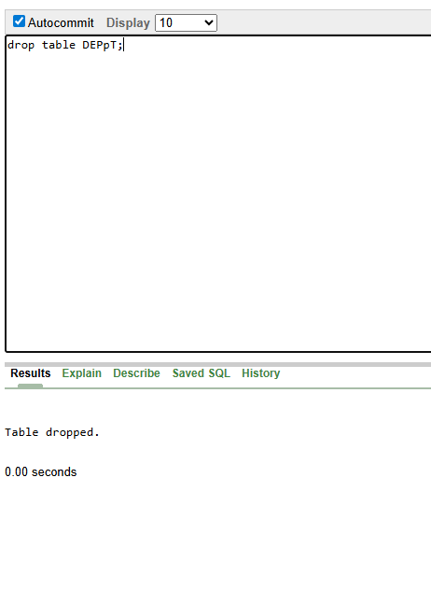
6,
Rename EMPLOYEES2 to EMPA;
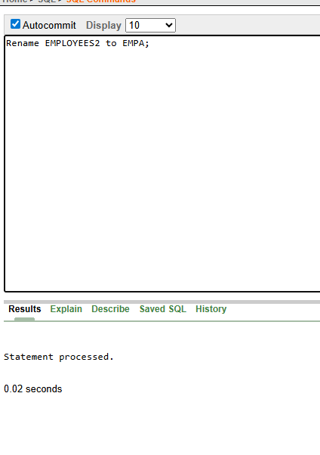
7,
comment on table EMPa is 'THIS TABLE NAME IS DEPpT'
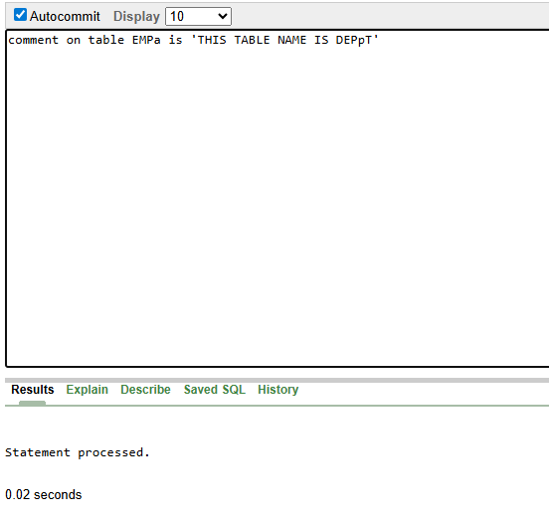
8,
alter table EMPa
drop column FIRST_NAME;
